Lab 6

1. Create a blank repository in GitHub under User A’s account called “GITLAB” with 1 Readme file. Print hub status. Both users A and B will use this repository. Add User B as collaborator to this repository.

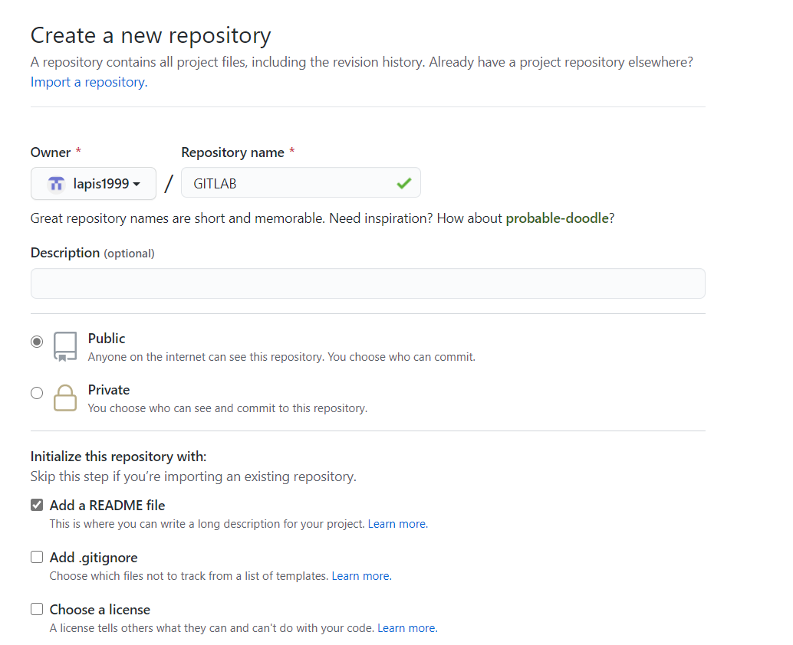

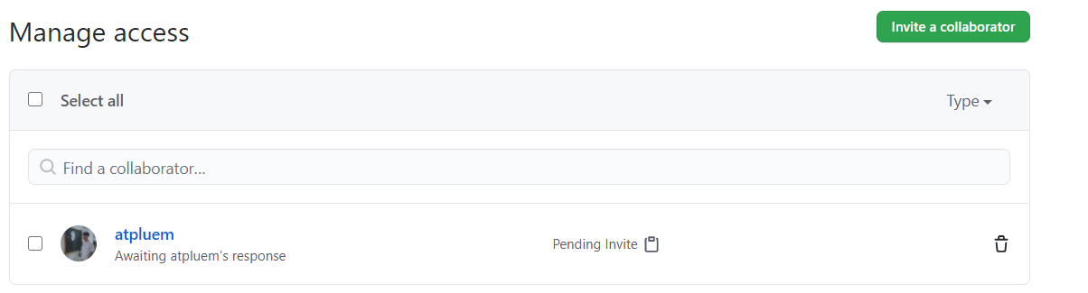

2. In some path create a folder called “CPE333-A” for User A. Make this a git repository and pull data from GitHub. Show status.

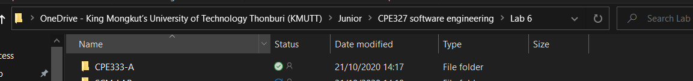

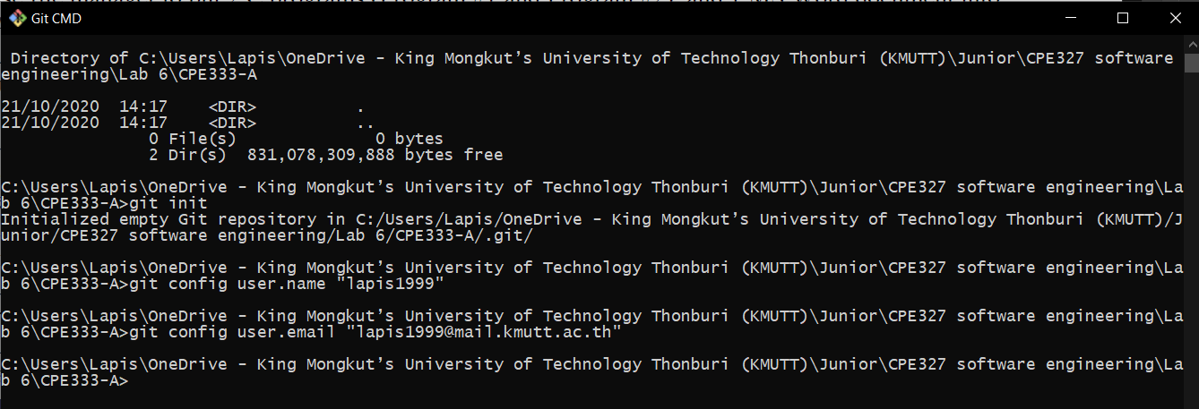

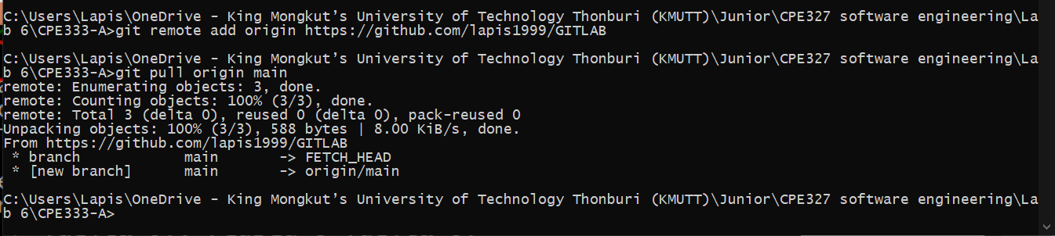

3. In some path create a folder called “CPE333-B” for User B. Make this a git repository and pull data from GitHub. Show status.

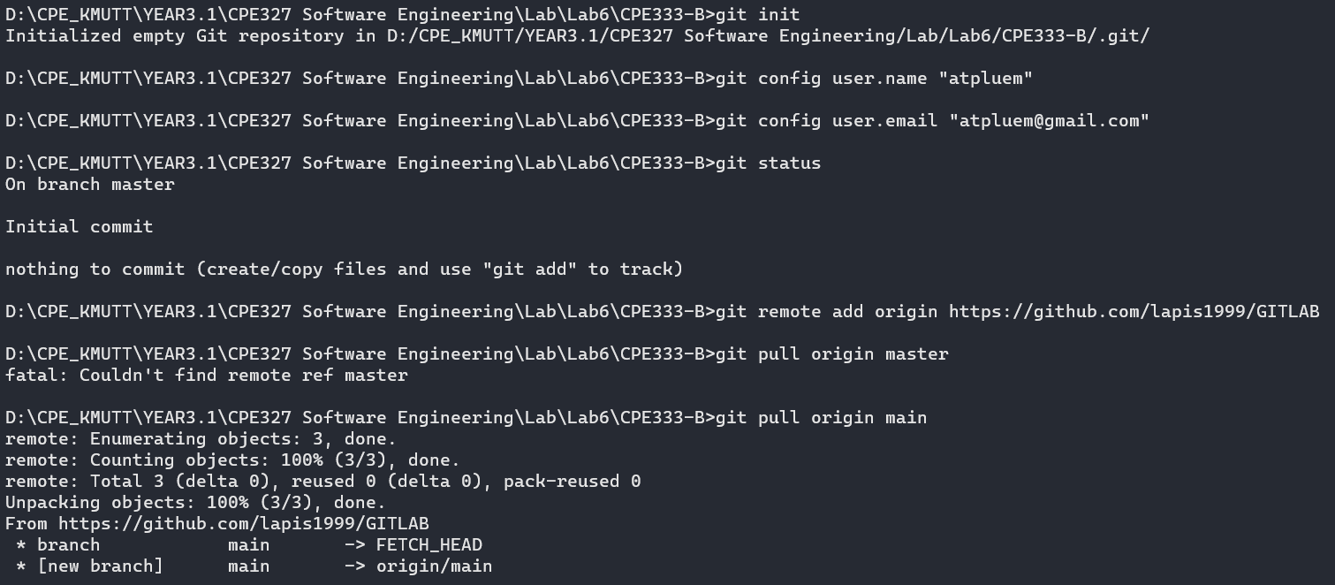

4. User A. Use file manager to put 2 C programs (Program #1 and Program #2), and 1 MS Word document into CPE333-A.